January Blog post for HCOE/Beth Baker
“Traveling – it leaves you speechless, then turns you into a storyteller.” – Ibn Battuta

A team of local math educators recently made the trek to Monterey to attend the annual CMCN math conference at Asilomar.
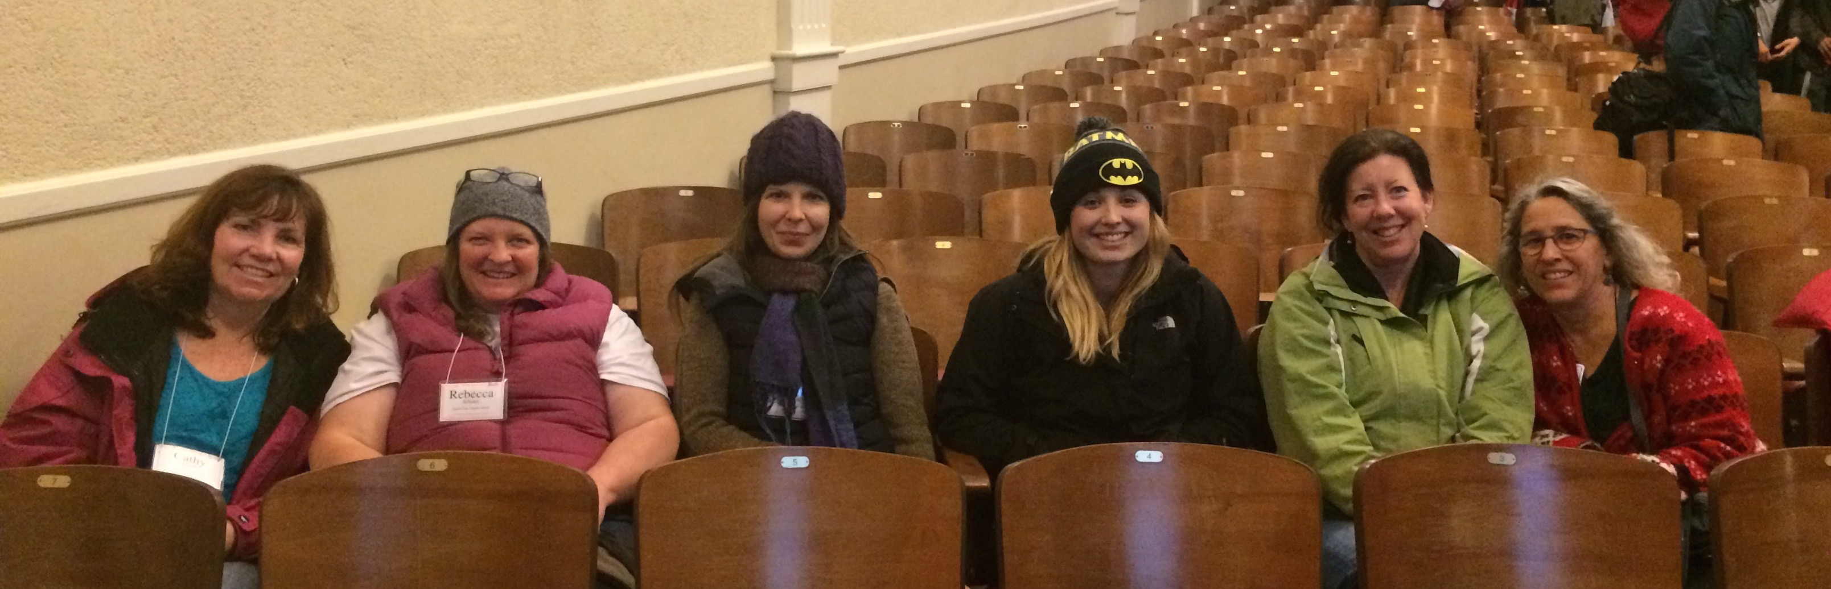
(Cathy Sinnen, Becca Schuler, Jessica Frisk, Alysha Simoni, Elizabeth Rivera, and Gwen Neu, after an inspiring keynote from NCTM president, Matt Larson-https://www.youtube.com/watch?v=RzumG4JvFZw)
Every year, dozens of presenters and hundreds of teachers converge to nerd out and swap epiphanies. Amazing keynote speakers challenge and inspire, casual conversations open doors to new ideas, and we all travel home with full brains, planning and plotting all the way.
For this, my first blog post for HCOE, I bring you the words and images of the team that attended, with the intent to inspire readers to plot their own next ed-venture. Many collegial friendships are formed during the ride from behind the redwood curtain and back again. The expense is real, but then so is the boost to teaching practices and connection to our local resources. Best of all, your teaching practice will mature and deepen into new pedagogies that you can deploy at will, wowing students and colleagues alike. You’ll even impress yourself at times!

Here, then are some testimonials and snapshots of what the conference was like.
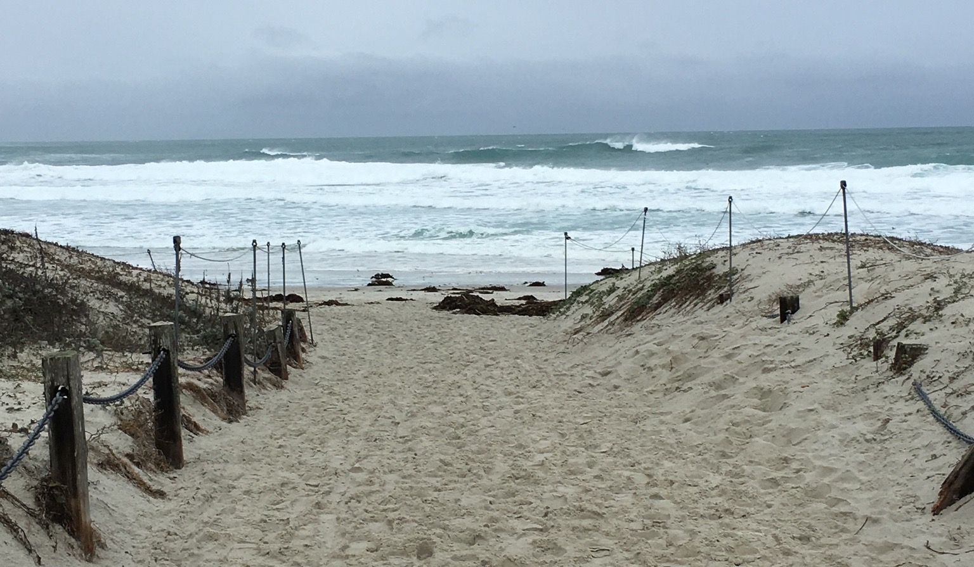
“We had fabulous conversations about math and learning, attended great workshops and made connections with colleagues, all in a beautiful setting.”

Cathy Sinnen
Math 7 & 8
Toddy Thomas
Fortuna
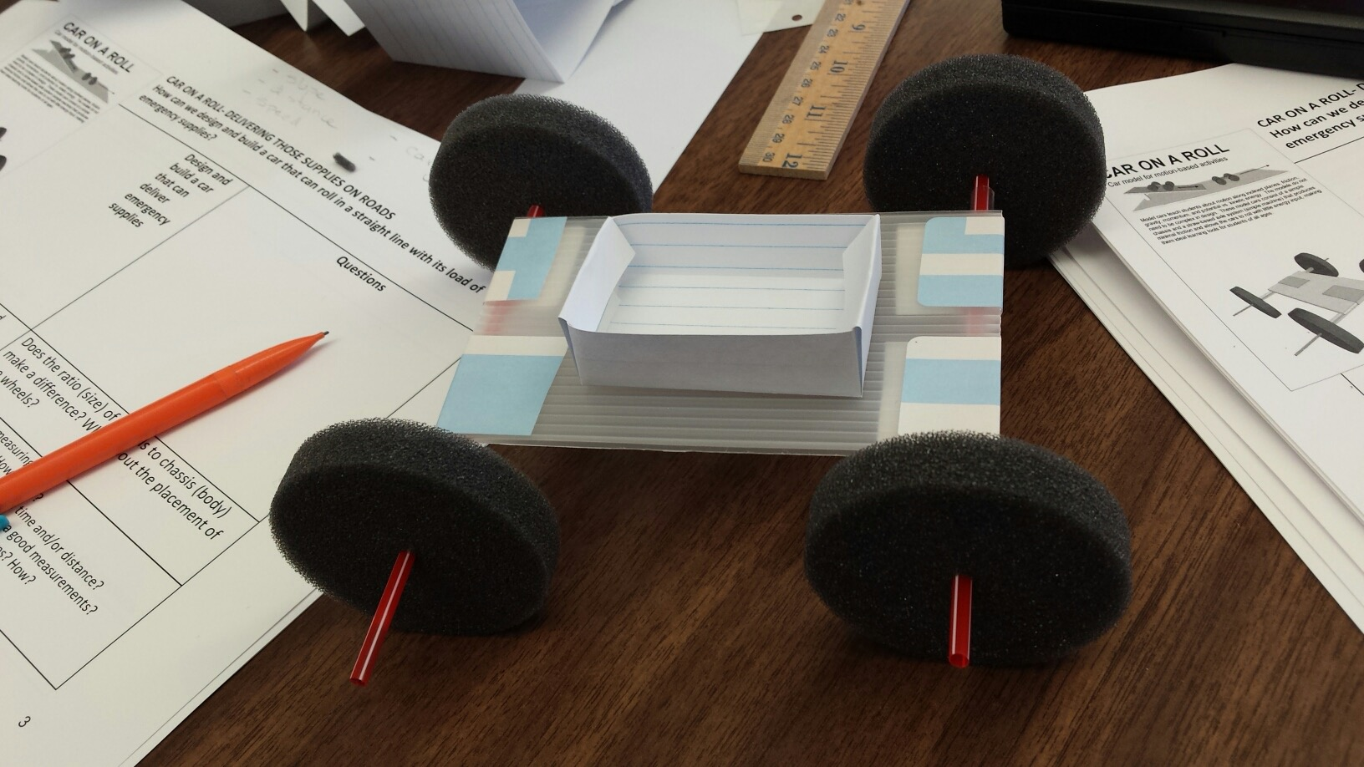
“It was amazing to get to know all of these dedicated teachers who I would not have met without this wonderful conference.”

Becca Schuler
Alg 2, Physics, Life Science
Laurel Tree Charter Arcata

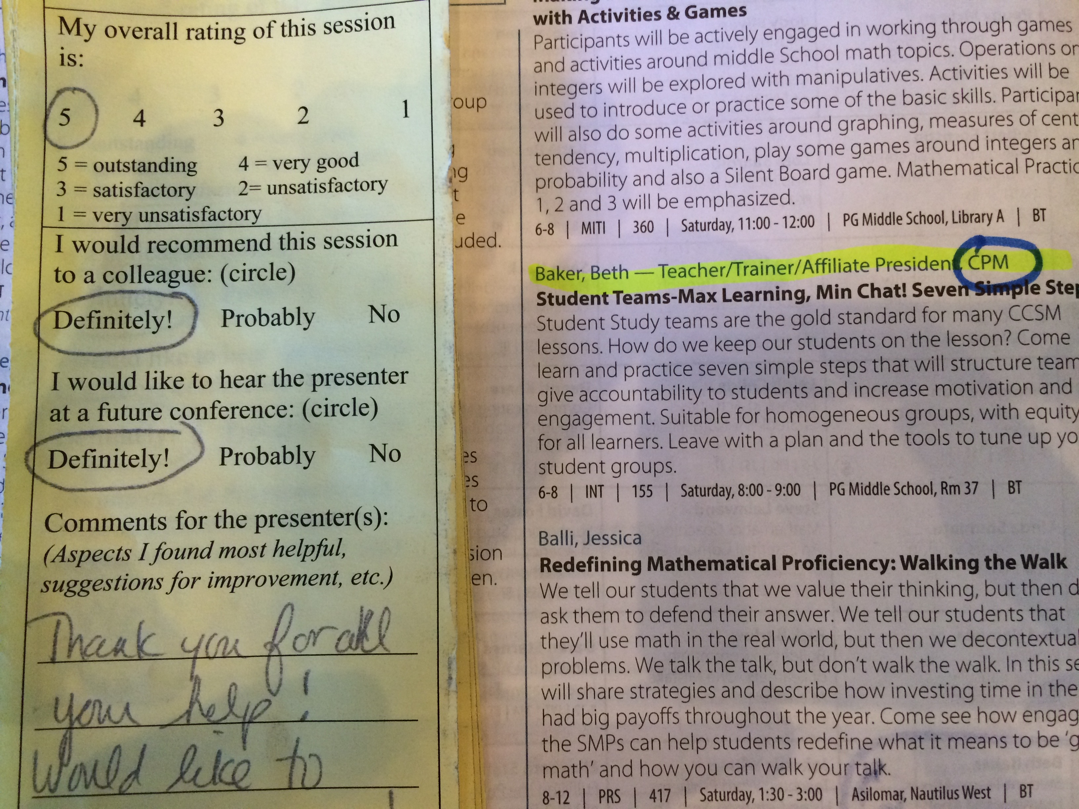
“To ride a shuttle where someone tells a math joke and everyone laughs...that’s a special moment.”

Beth Baker
CMCFN President
Math 8
Zane Middle School Eureka

“Asilomar provided amazing pd opportunities to attend hands on, engaging mathematics workshops as well as collaborate with math teachers from across the state. I brought back lessons I am ready to implement in my classes and new found professional relationships with colleagues both in Humboldt County and throughout California.”
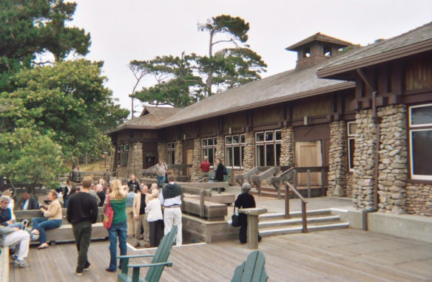
Jessica Frisk,
Alg 1 to Pre-Calc,
Ferndale High School, Ferndale

CMCFN Scholarship Winner
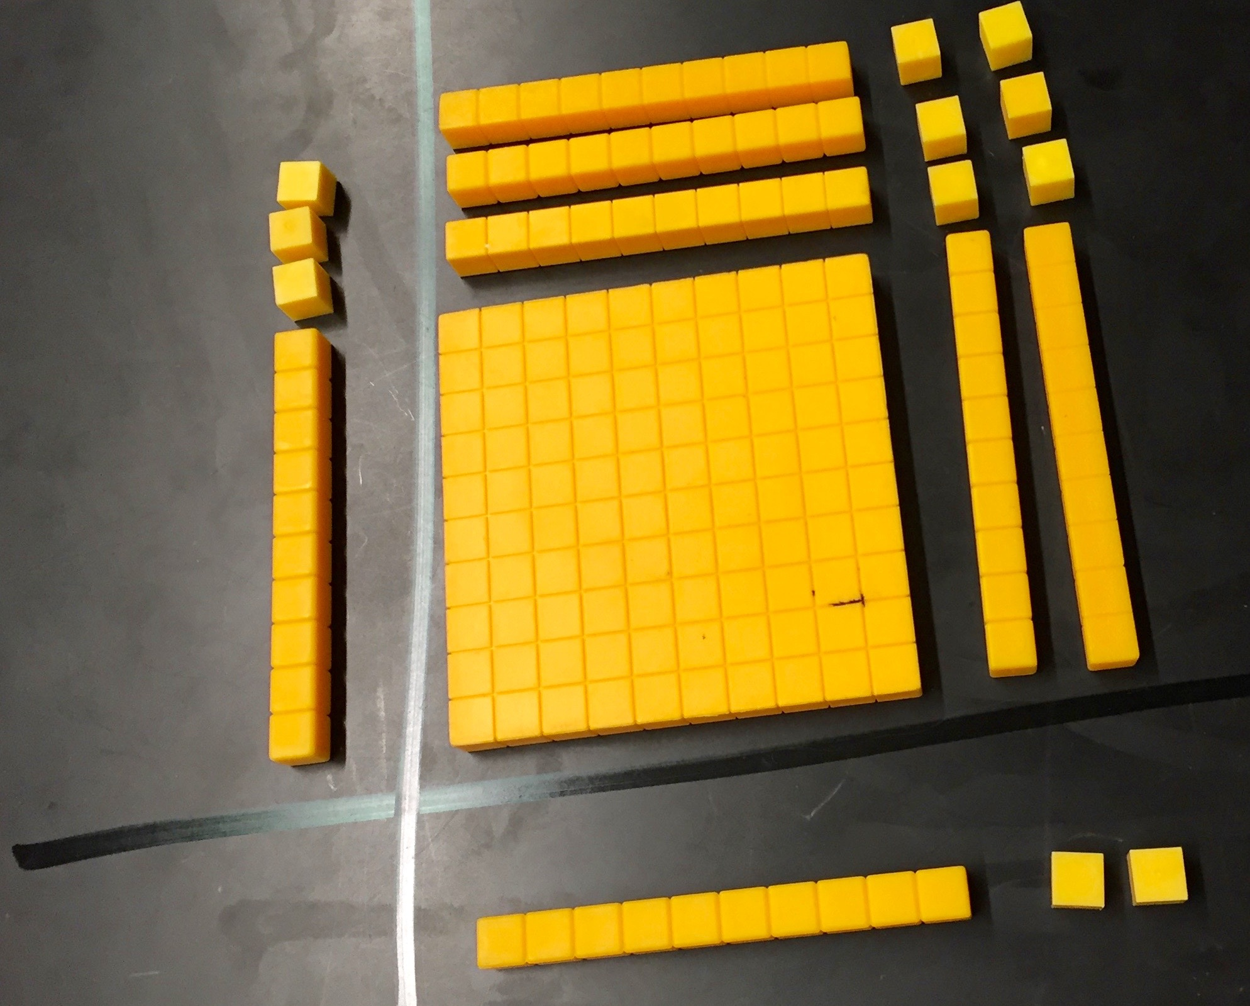
“We had a great time collecting teaching ideas and expanding our mathematical thinking.”

Elizabeth Rivera,
Morris Elementary, McKinleyville

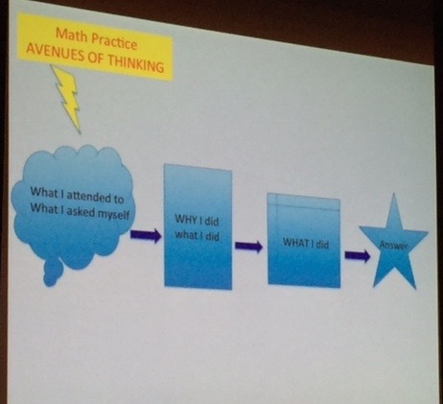
“I have been using this for my math talks, and it’s working. My students are slowly understanding ‘it’s about the process not (just) the answer’.”

Gwen Neu,
CMCFN President Elect
All subjects, Maple Creek School, Maple Creek

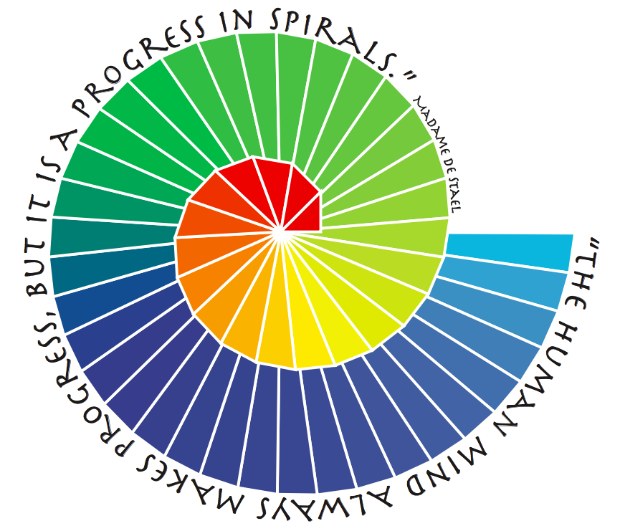
“As a young teacher, I am always looking for a way to better my teaching practices. The workshops and conversations I participated in at Asilomar have been more than I could have hoped they would be.”

Mark Thom,
Alg 1 and Chemistry,
Academy of the Redwoods, CR

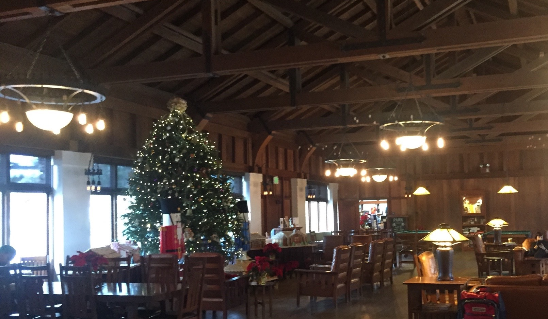
“Asilomar was such an amazing experience with insightful seminars and wonderful company.”

Alysha Simoni, Kindergarden,
Alice Birney Elementary, Eureka

CMCFN Scholarship Winner

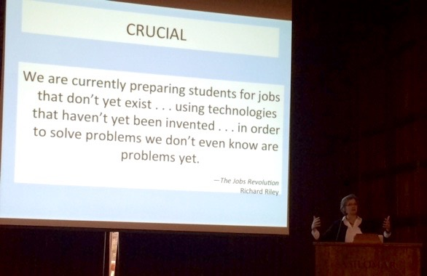

(From Keynote Grace Kelemanik, Teacher Educator, Boston Teacher Residency Program
The Eight Standards for Mathematical Practice: Overwhelming and Under Realized)

This year’s program link is included below....to provide inspiration to next year’s attendees.
http://cmc-math.org/temp/wp-content/uploads/2013/05/2015-Asilomar-Program.pdf
Another favorite at Asilomar is the Ignite Talks, here is a link to my favorite, the content is so great the lousy video quality becomes less of an issue – I’m using this lecture on my 8th graders soon. https://www.youtube.com/watch?v=VxcnOhG60sM
(if the link doesn’t work, just paste into your browser)

The next time a flyer shows up in your box or email, consider this: maybe don’t just put it aside, instead, start hatching a plot to take a team and feel the excitement that will percolate into your teaching and your students’ learning! Contact me: Bethbaker52@gmail.com or visit my slightly under-maintained website, at bethbakermath.com.

Resources-find a conference near or far, and GO!
NCTM National Standards http://www.nctm.org
CMC State Math conferences http://cmc-math.org
CMCFN Local math conference http://www.cmcfn.com
HCOE PD site http://my.hcoe.net
Great resource sites:
Illuminations amazing lessons pK-12 https://illuminations.nctm.org
Desmos easy to use free graphing calc. https://www.desmos.com
Sumdog motivating fun drill for elem. http://sumdog.com

Thank you for all you do for our youth, and thank you for reading,
Beth Baker
Zane Middle
Math 8

Coming up next month: SBAC (or CAASPP, if you prefer) and how to prep for it while keeping the focus on learning and the stress level low

